**Group 5- Inventory System**

**[fc69d03fa6b7634d7b7c30e423f14784db1802d3]**

**G2-DD/Screen Transition and Layouts**

**Members:**

**Jude Bontigao**

**Deony Diras**

**Mark Imperial**

**Mikmik Lanada**

**Raven Sicat**

**Add**

**Add New inventory Item Details Screen**

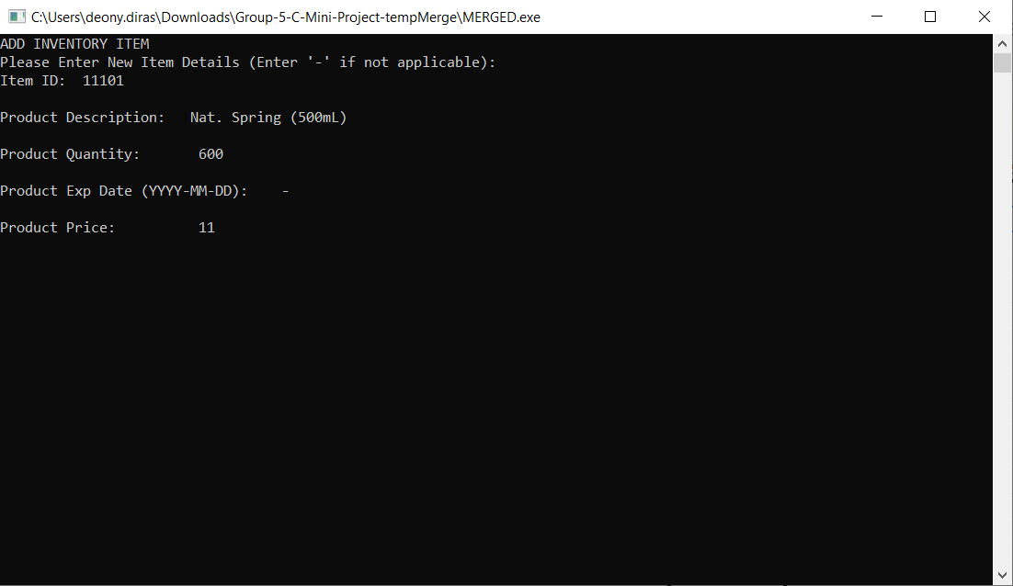

**Adding Confirmation Screen**

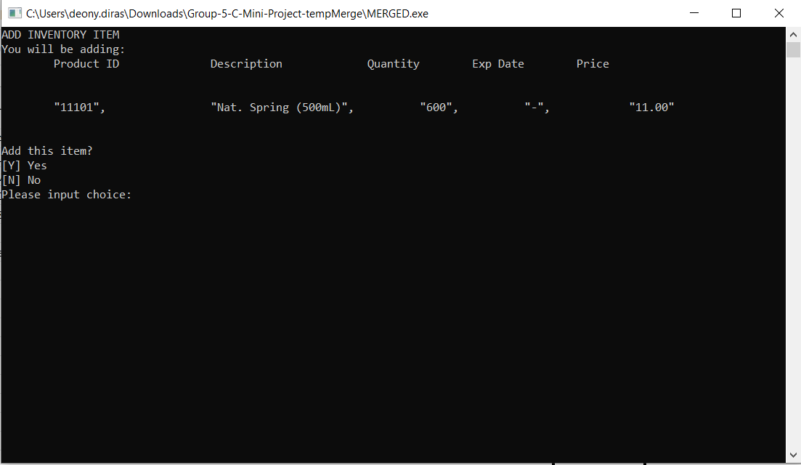

**Adding Successful Screen**

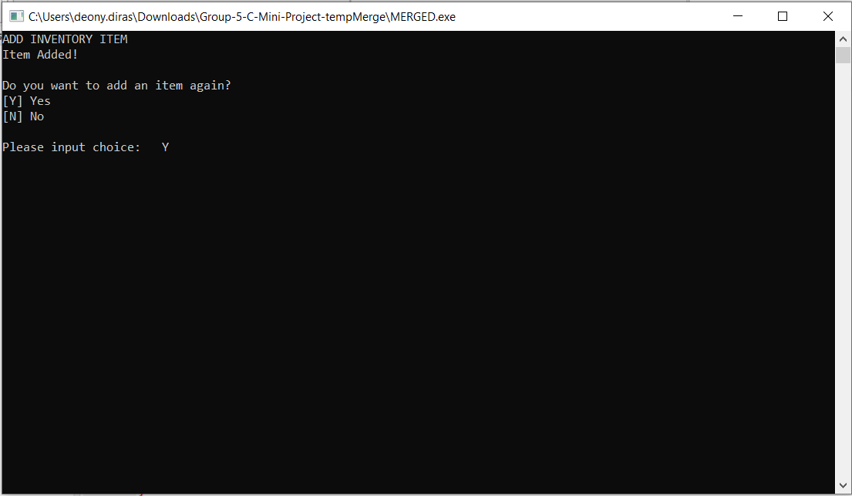

**Update Inventory**

**Update Inventory Menu Screen**

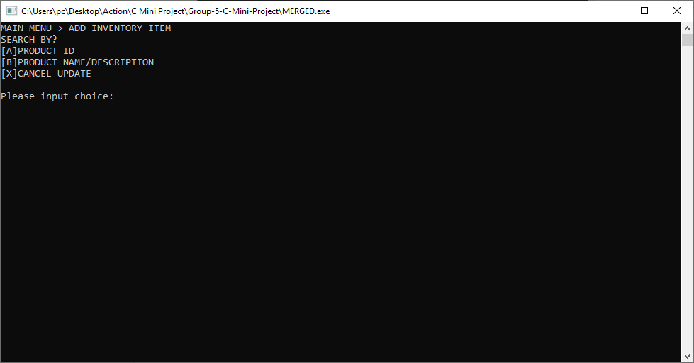

**Update Inventory Menu Screen (Choice A)**

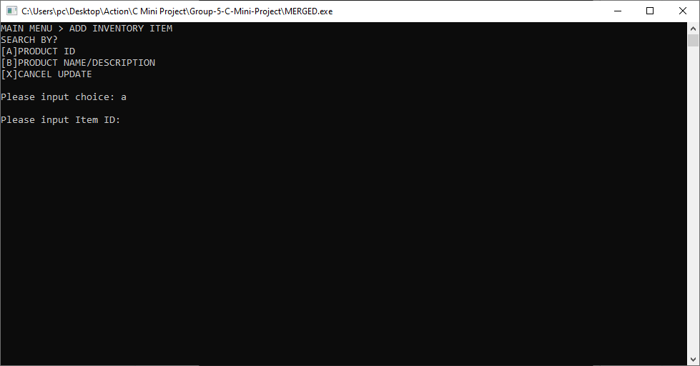

**Update Inventory Menu Screen (Choice B)**

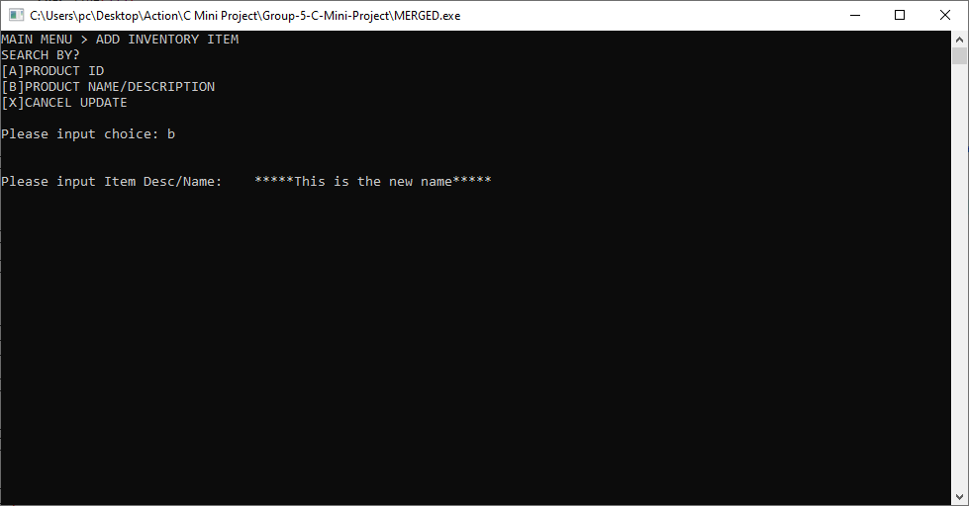

**List of Items w/ same Description Screen**

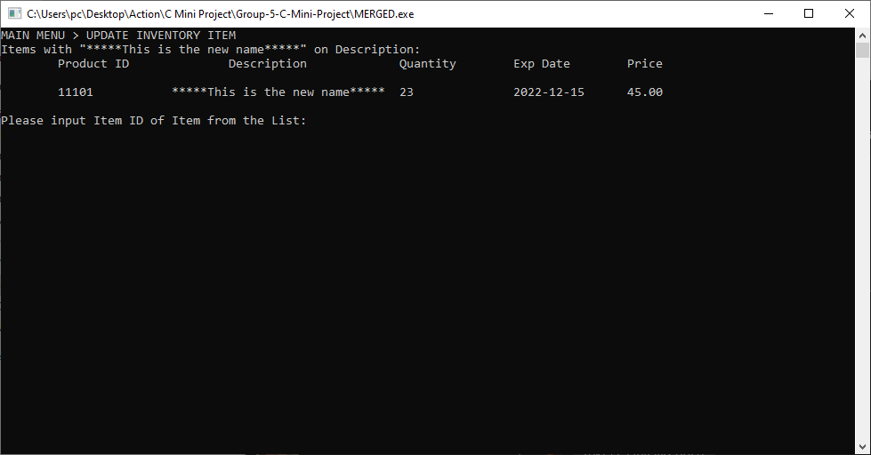

**Enter New Item Details Screen**

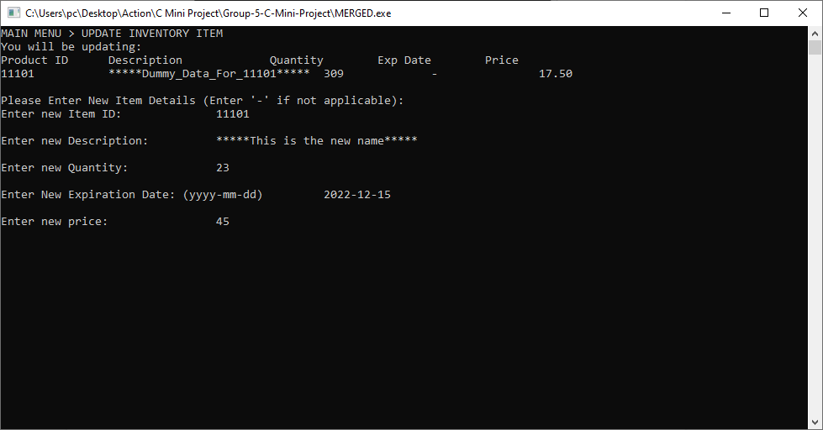

**Update Confirmation Screen**

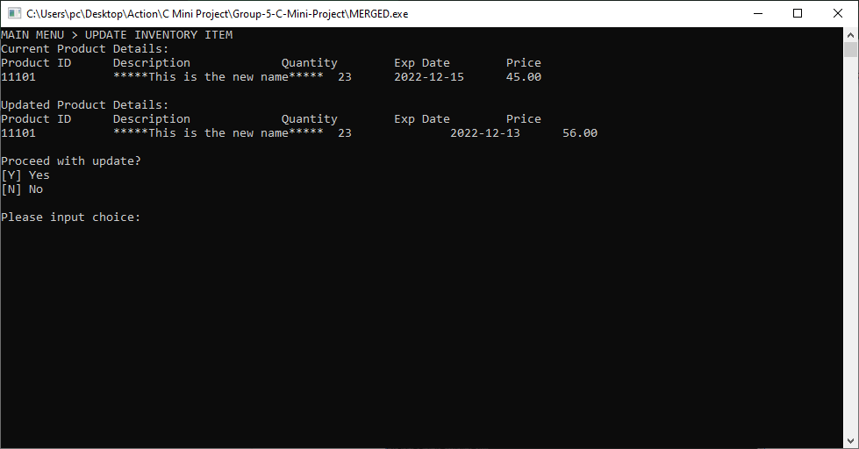

**Update Successful Screen**

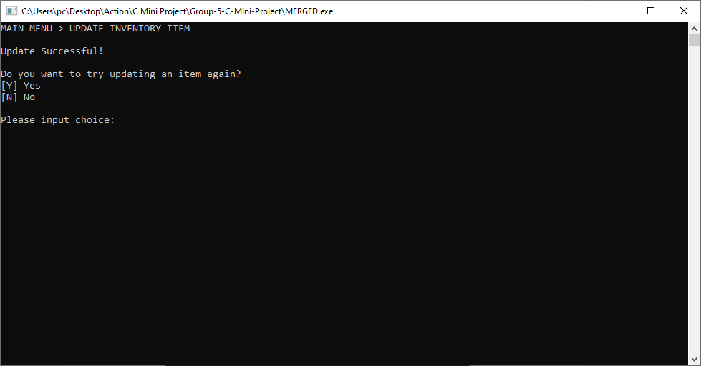

**Update Invalid Input**

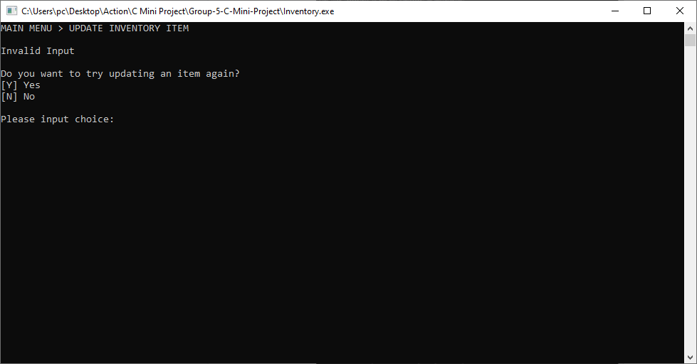

**Update Cancelled**

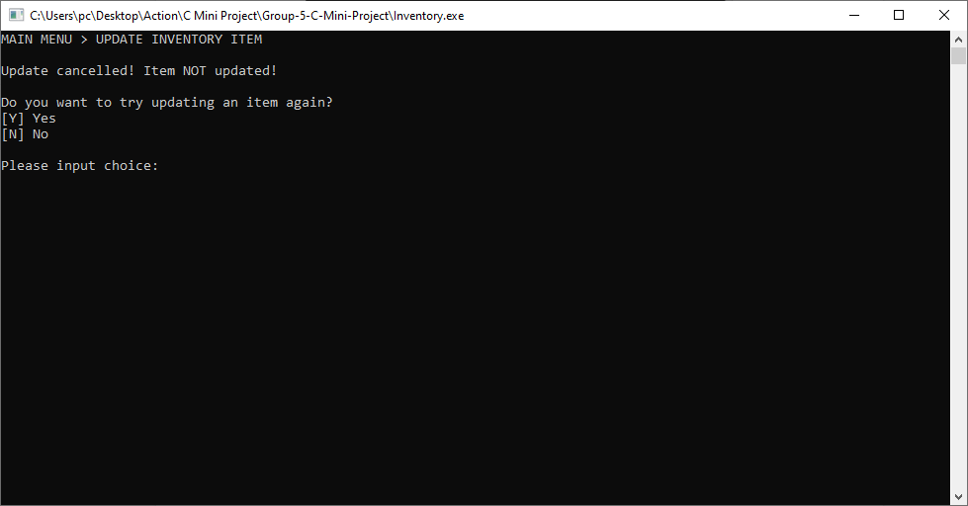

**Update Product ID Already Used**

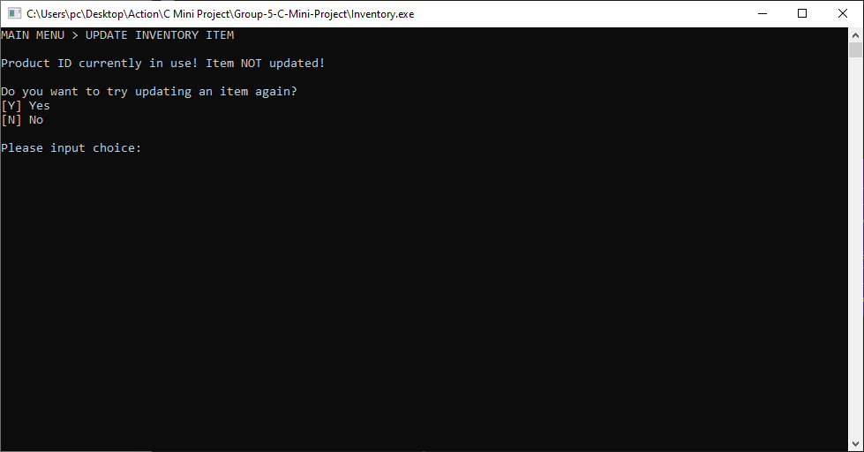

**View Inventory**

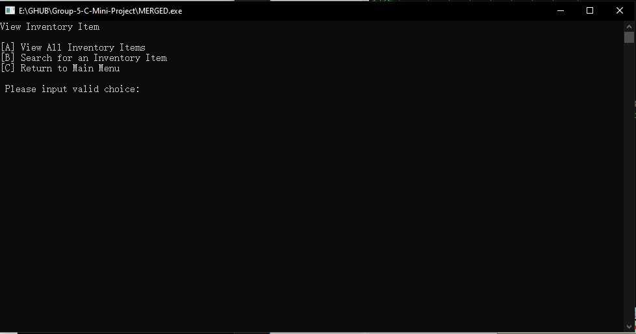

**View All Inventory Items Menu**

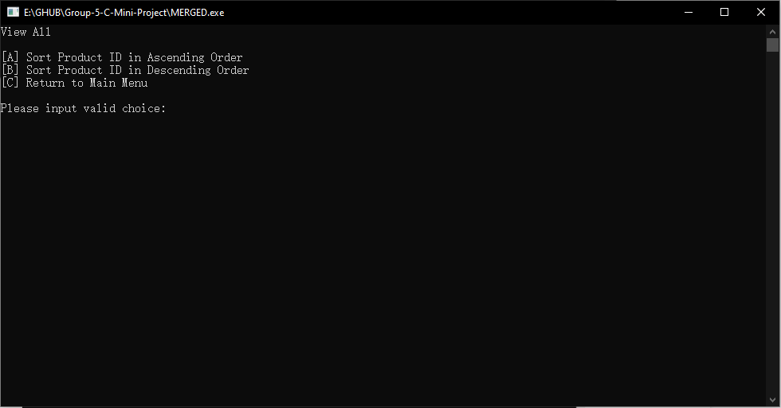

**Inventory Sort (Ascending Order)**

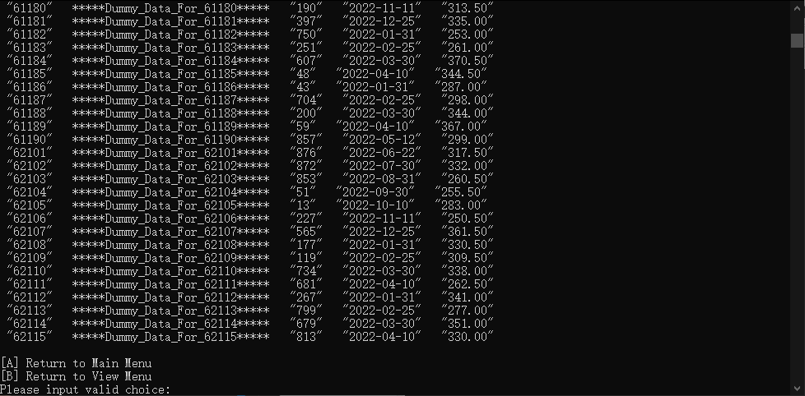

**Inventory Sort (Descending Order)**

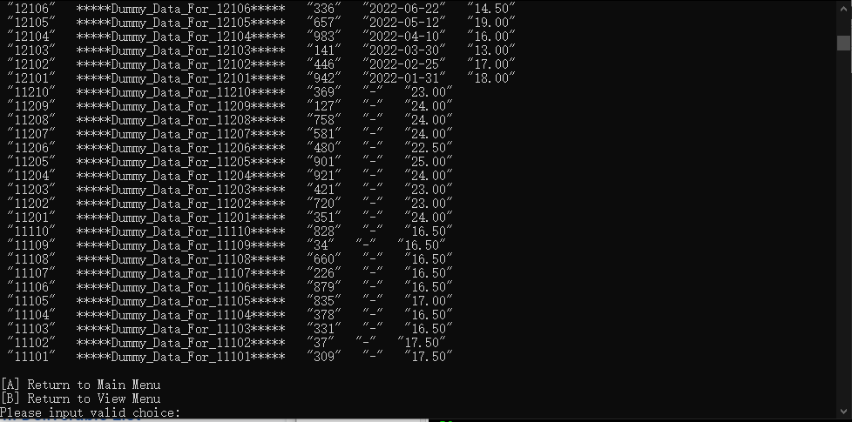

**Search**

**Search for an Inventory Item**

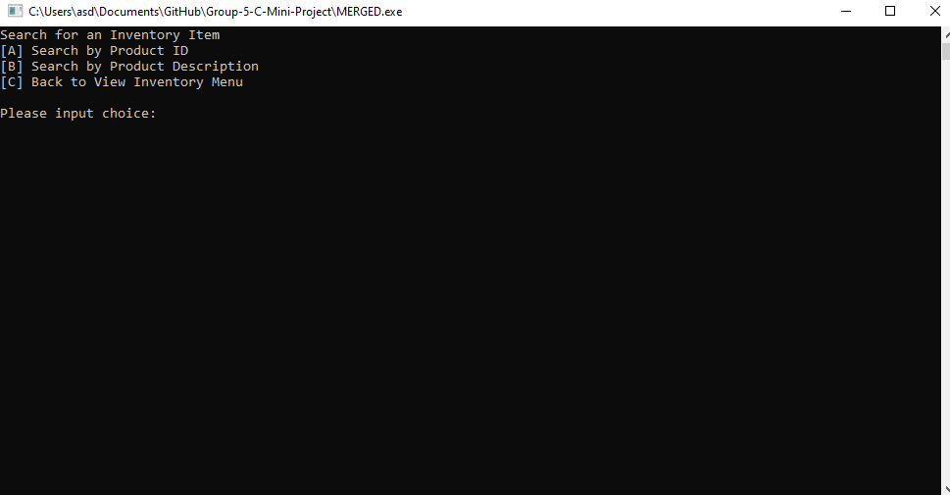

**Invalid Search for an Inventory Item Input Data**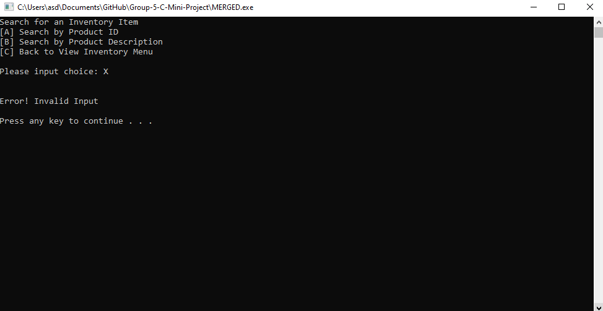

**Search by Item ID**

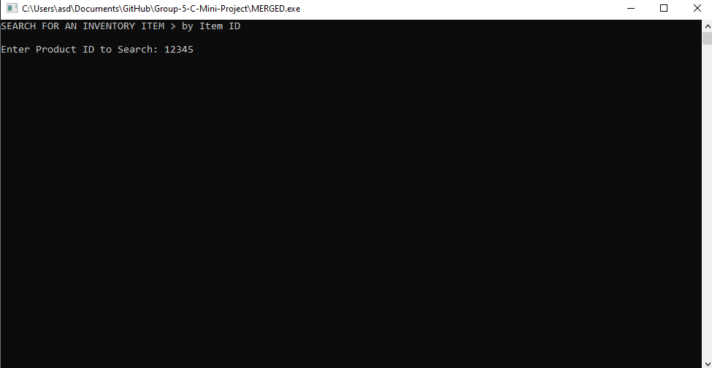

**Show Item Informations using Item ID**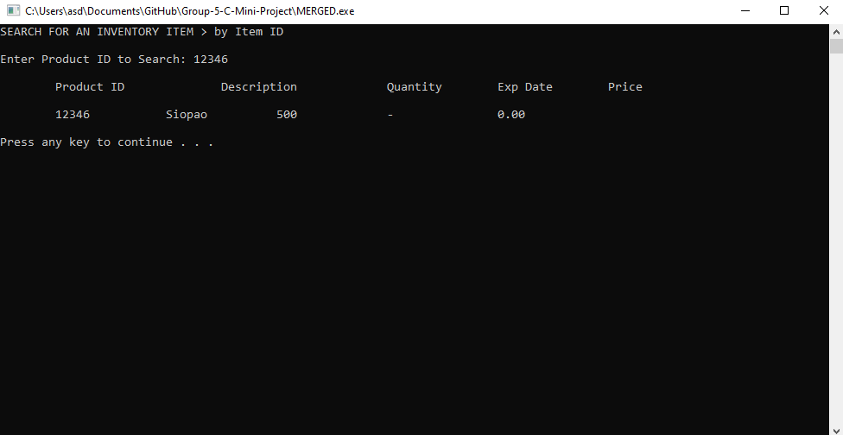

**Invalid Item ID Input**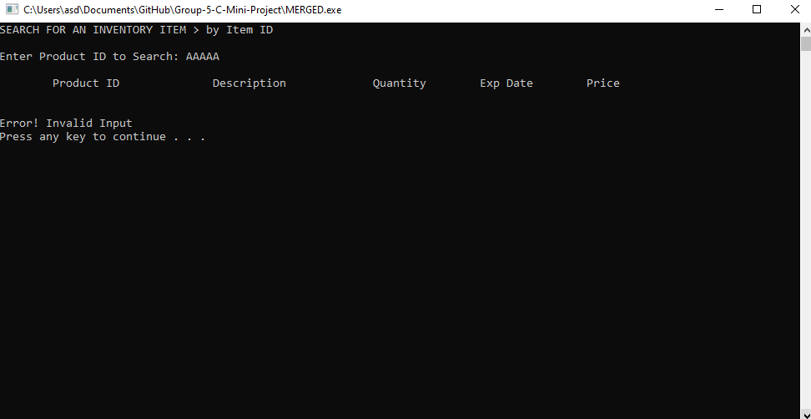

**Item ID does not exist**

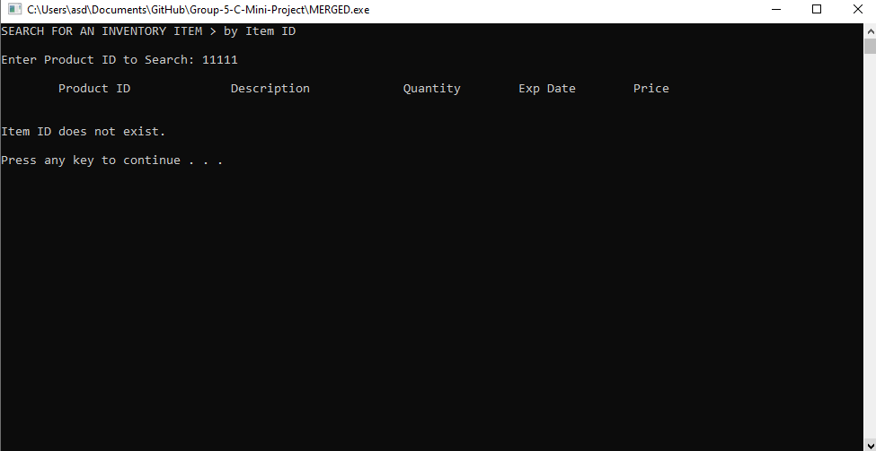

**Search by Item Name**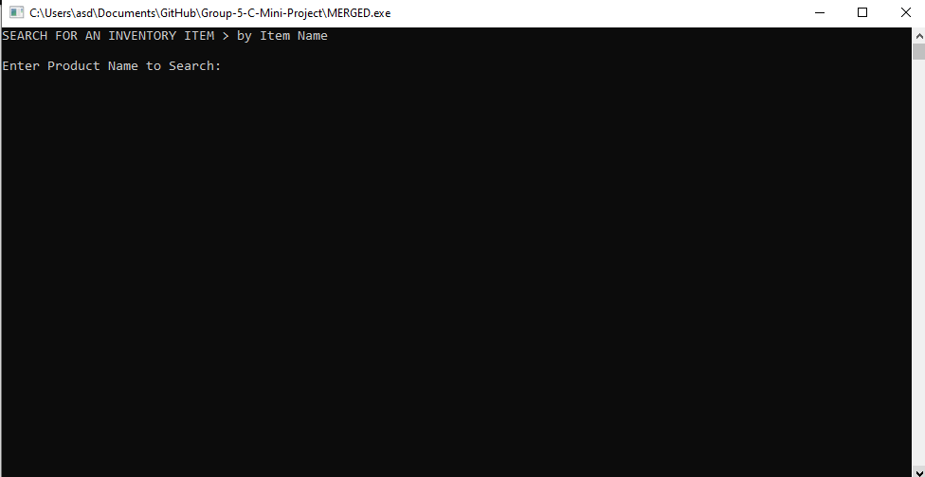

**Show Item Informations using Item Name**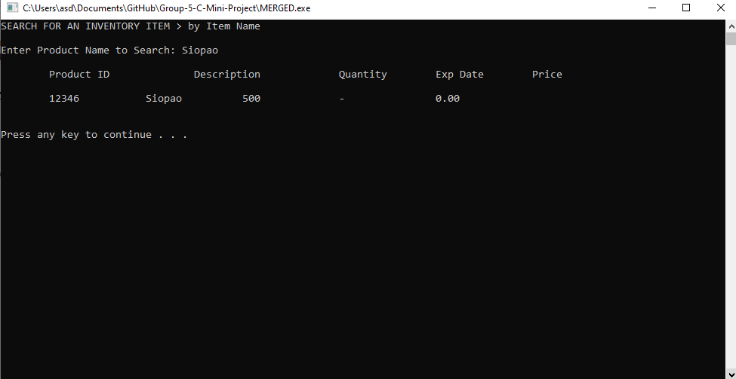

**Item Name does not exist**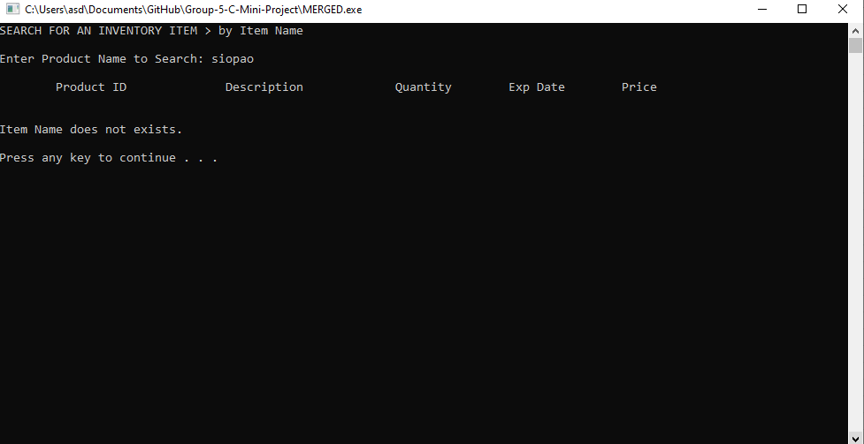

**Delete**

**Delete Menu Choice**

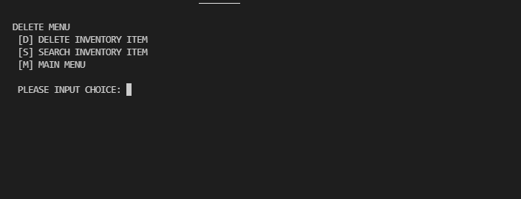

**Delete Item Menu**

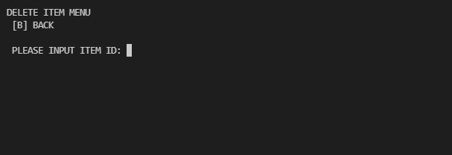

**Delete Confirmation**

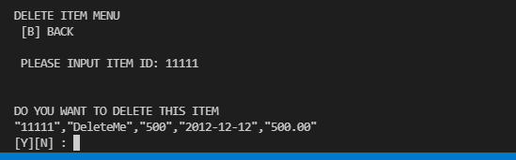

**Delete Successful**

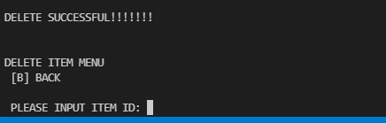

**Invalid ID**

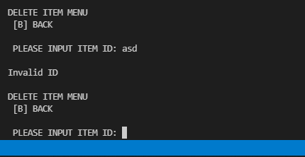

**ID does not exist**

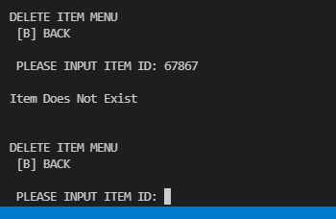

**Main Menu Screen**

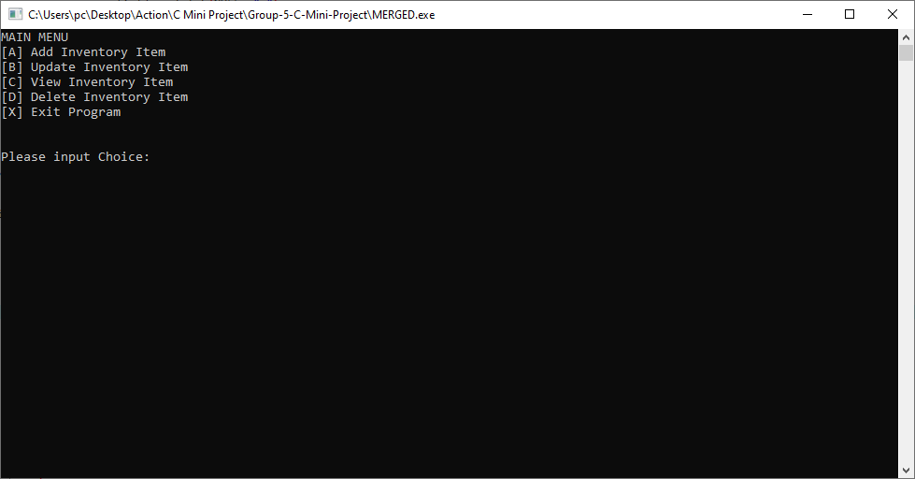

**Exit**

